HEROKU

Publish your web pages on Heroku. For free!

Heroku is a container-based cloud Platform as a Service (PaaS). Developers use Heroku to deploy, manage, and scale modern apps.

<https://www.heroku.com/>

Sign up for your free account

Click **Sign up** button on Heroku landing page

Complete the sign up form and make sure you select **Node.js** as your **Primary Development Language**

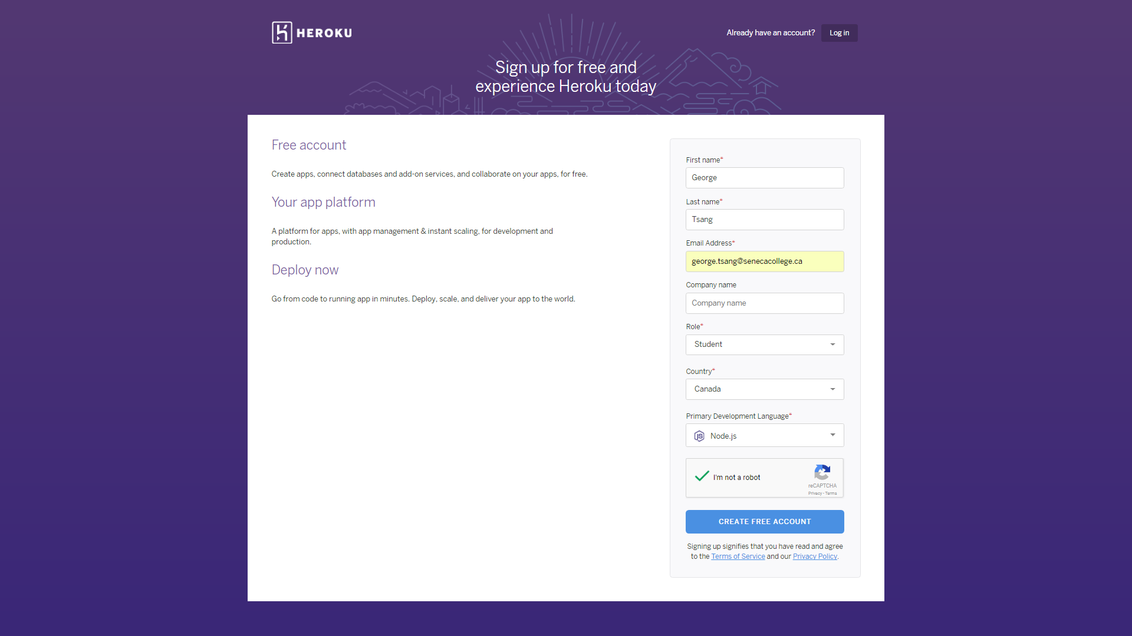

Learn the basics by reading the document **Getting Started on Heroku with Node.js** on Heroku website <https://devcenter.heroku.com/articles/getting-started-with-nodejs#introduction>

Necessary Software

In addition to **Node.js** and **Visual Studio Code**, you will need to download and install **git** (a version control system for tracking changes in files) <https://git-scm.com/downloads> and **Heroku CLI (**Command Line Interface) <https://devcenter.heroku.com/articles/heroku-cli>

Publish your webpage(s) on Heroku

Before commence publishing, verify your readiness by reviewing the following:

1. You have fully tested your web server application on your local host
2. You have an active Heroku account
3. You have downloaded and installed necessary software such as **git** and **Heroku CLI**
4. You have verified successful installations by issuing the commands

**git --version**

**heroku --version**

1. You may need to do the following to enable you to logon to your Heroku account from your integrated terminal:
   1. git config --global user.email “george.tsang@senecacollege.ca”
   2. git config --global user.name "george tsang"
2. You have created a text file and named it **Procfile** (without extension) in the root directory of your application; **Procfile** should contain a single line of declaration:

**web: node yourwebserverfilename.js**

1. Your PORT selection should be coded as

**var HTTP_PORT = process.env.PORT || 3000;**

while code the following to commence *listening*:

**var server = app.listen(HTTP_PORT, function () {**

**console.log(“Listening on port “ + HTTP_PORT);**

**});**

After confirming your web server’s readiness, you can proceed by:

1. Open the **Integrated Terminal** on VS Code
2. Issue the command **git init** then
   1. Click the Source Control icon in the Activity Bar
   2. Check to see if **Changes** is greater than zero
   3. If so, click the plus (+) sign with tool tip “**Stage All Changes**”
   4. Next enter your own **release note** in the **Message** textbox
   5. Then click the checkmark above the textbox to commit changes
3. Issue the command **heroku login** (wait for the Heroku login webpage then enter your email address and password)
4. Issue the command **heroku create *firstname-lastname-assignmentname***
5. Issue the command **git push heroku master** to deploy your web server application
6. Open a browser and enter URL **firstname-lastname-assignmentname.herokuapp.com**

If you need to delete your app from Heroku:

1. Logon to your Heroku account
2. On your Heroku apps/home page, click on the app you wish to delete
3. On the new webpage, select the **Settings** link at the top
4. On the settings webpage, scroll to the bottom and click the **Delete app…** button
5. Confirm deletion by entering your app’s name in the dialogue box’s textbox
6. Click the **Delete app** button on the dialogue box

To check your application’s current URL:

1. git remote -v

To remove your remote url

1. git remote rm Heroku

To update your Heroku to a new version

1. Heroku update